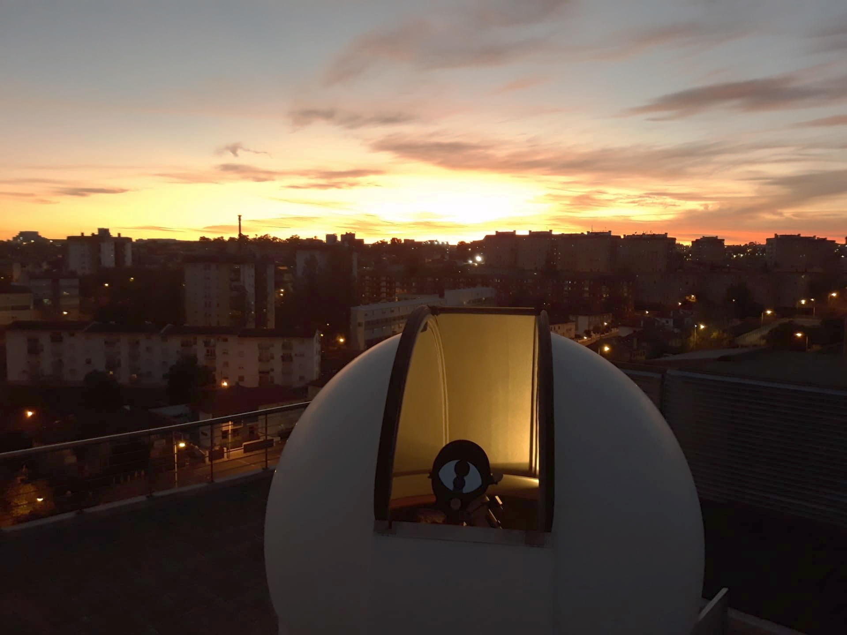

CIGeoE Telescope
Application for observing time

Period: 2025B

TITLE
Broadband Imaging and Photometric Study of the Planetary Nebula M27

ABSTRACT (max. 100 words)
The study of planetary nebulae is essential for comprehending the final phases of stellar evolution. The Dumbbell Nebula (M27) is bright and well-placed for a comprehensive CCD study. We aim to obtain broadband B, V, and R FITS images to characterise its surface brightness, radial profile, colour variation maps, and the photometry of its central white dwarf. Radial profiles and colour maps will provide insights into its shell structure and ionisation, while the central star photometry links to stellar evolution. A total of 3 hours of integration will secure the required SNR under Lisbon sky conditions.
y
3

Total time requested (hrs):

Moon conditions (‘d’,’g’,’n’):
n

Camera requirement (‘y’ or ‘n’):
B, V, R
Filters required (BVR):

Investigators
Jan Wiegand
Jonathan Bauer
Vasco Soares
We want to observe the planetary nebula M27 because it is a bright and well-placed target during our September observing window.

On September 15 the nebula will be located almost at the zenith during the observation time. It is also far away from the Moon, which again speaks for favorable observation conditions.
Another important factor is the position of the nebula with respect to the local environment, especially the airport. M27 is located between southeast and west over the course of the night. Since the airport lies approximately between southeast and northeast, it will not interfere with our observations.

The angular apparent size of the nebula (~8′ × 6′) fits very well within the field of view of our CCD (9′ × 9′), allowing us to capture the entire nebula in a single frame.
M27 has two main aspects of observational interest: the extended ionized gas shell and the faint central white dwarf. This makes it an ideal target for practicing both extended-source imaging (surface brightness profiles, color composite mapping, etc.) and stellar photometry.

Scientific Rationale (max. 450 words)

Targets
NAME | α (J2000) | δ (J2000) | Time on target | Mag | Additional info
M27 | 19h 59min 36s | 22° 43’ 16’’ | 180min | 12.60

Observing plan suggestion and time justification (max 150 words, figures allowed)

References

Panel Evaluation (leave blank):
Abstract (20%):
Scientific rationale (40%):
Observing plan and time justification: (40%):

